Linked List
Monday, December 2, 2024
11:00 AM

  - Merge Linked List
  - Remove Duplicated from a linked list
  - Reversal of Linked List
  - Linear Search In a Linked List
  - Find Middle Node of a linked list
  - Find Middle Node of Linked List using Stack - C++
  - Polynomial representation using linked list - (optional)
  - Check for loop in a Linked List

1:How delete[] knows how much memory to deallocate
Saturday, April 5, 2025
8:43 AM

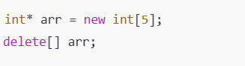
- Tells the compiler,we're allocating 5 integers in the heap ,but we are not passing that numbers to delete[].Why?
Trick : Hidden size storage :- new[]
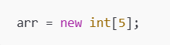
Internally it becomes
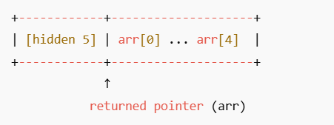
- When delete[] arr is being called ,at runtime it does
  - Looks just before the pointer to get the count
  - Calls the destructor of each element(if they are objects)
  - Frees the whole block

Q:- Why we cant call
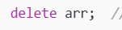

- It will result in undefined behavior as it cant call the destructors ,it will corrupt the heap and leak memory.

2.Reference vs Pointers in C+
Saturday, April 5, 2025
8:44 AM

Pointers
- Variables that hold memory addresses. They store the memory location of another variable.
- Can be null (point to nothing). You can explicitly assign nullptr (or NULL in older code) to a pointer.
- Can be reassigned to point to a different variable. The address stored in a pointer can be changed.
- Require explicit dereferencing (*) to access the value they point to. You need to use the * operator to get the actual value at the memory location.
- Support pointer arithmetic. You can perform operations like incrementing or decrementing pointer values to move through memory (e.g., for arrays).
References
- Aliases for existing variables. Once a reference is initialized to a variable, it becomes another name for that same variable.
- Cannot be null. A reference must always refer to an existing object upon initialization.
- Cannot be reassigned to refer to a different variable after initialization. Once bound to a variable, a reference always refers to the same variable throughout its lifetime.
- Implicitly dereferenced when used. You can use a reference directly as if it were the original variable.
- Do not support pointer arithmetic. Since they are aliases, arithmetic operations on references act directly on the underlying variable

When to use references?
- When we're certain that refered object will always exist and we don’t need to reassign
- Pass by reference :- avoid copying the argument and allows function to directly modify the refered object
- Operator overloading :- To return alias of an existing object .
- In Range-based For loops:- Used in range-based for loops to directly access and potentially modify the elements of a container without making copies .

3.How vector works internally in C++
Saturday, April 5, 2025
10:06 AM
  - Vector in C++ is a dynamicallly allocated array .It manages a pointer to the memory block where elements are stored contiguosly.
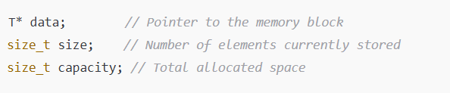
  - When we insert elements into vector using push_back()
    - If size < capacity :- new elements are placed at the end .
    - If size == capacity :- vector allocates a bigger block ,copying existing elements to the new block ,deletes old one and inset new items .
  - Typically capacity grows by 1.5x or 2x (Implementation -dependent) to reduce frequent allocation.

4.Write atoi function in c & c++
Saturday, April 5, 2025
10:40 AM
C Implementation
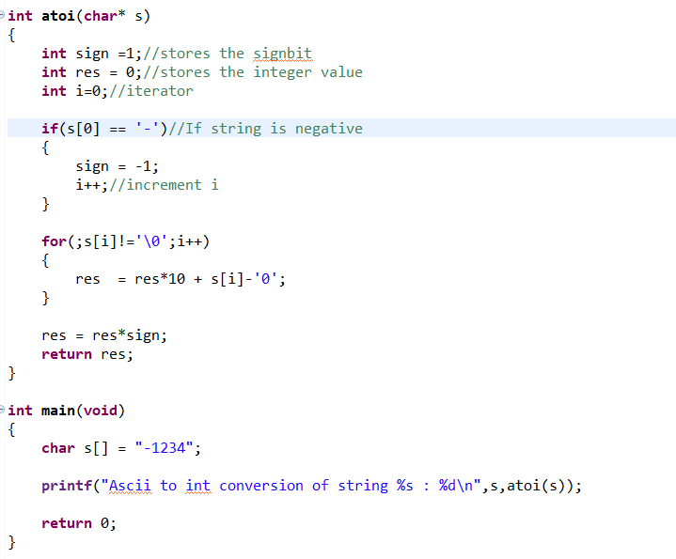

C++ Implementation

5.Plain Enum vs Enum Class
Saturday, April 5, 2025
1:02 PM
- Enum and Enum classes are used to create user defined types consisting of set of named constants.

Enum (unscoped )
- Enum will cause name clashes if we are using same constants in different enums within the same scope
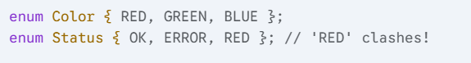
- Implicit conversion of enum ,will leads to type errors
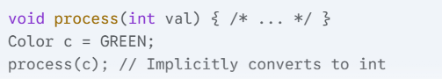
Enum Class(Scoped)
- Enum class are strongly scoped ,to access enum class members we need scope resolution operator.
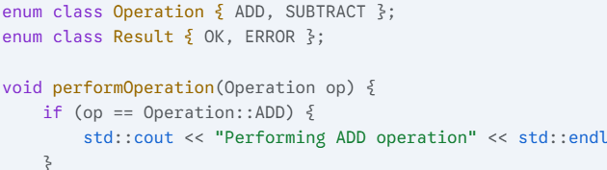
- No name conflict when we repeat enum class members
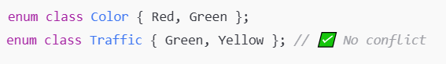
- Green can be accesed either as Color::Green or Traffic::Green ,hence no conflict
- Implicit conversion of enum ,will leads to type errors

6.Little Endian vs Big Endian
Saturday, April 5, 2025
4:31 PM

  - In little Endian ,Least significant Byte (LSB) will be stored first .
e.g :- 0x12345678 will be stored as
78 56 34 12
  - Most processors are little endian.
  - In Big Endian ,Most significant Byte (MSB) will be stored first
e.g:- 0x12345678 will be stored as
12 34 56 78
  - e.g Network Protocols (TCP/IP)

7.How to prevent taking address of an object in C++
Saturday, April 5, 2025
4:39 PM

  - Method 1:- Make & operator private
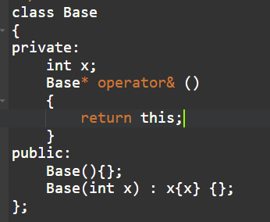
  - Method 2:- Delete & operator
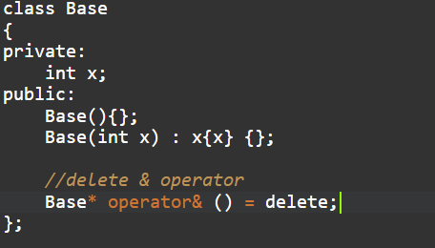

8.Function returning an array in C++
Saturday, April 5, 2025
8:12 PM

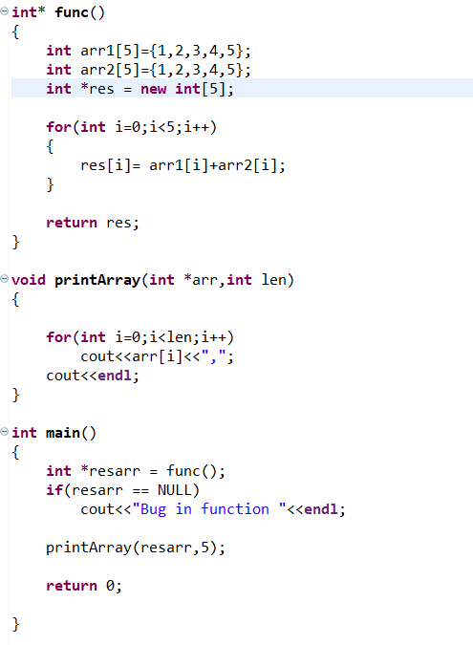

9.Call a function before main function
Saturday, April 5, 2025
8:15 PM
- Call the function inside the constructor of a class ,and instantiate that class object as global

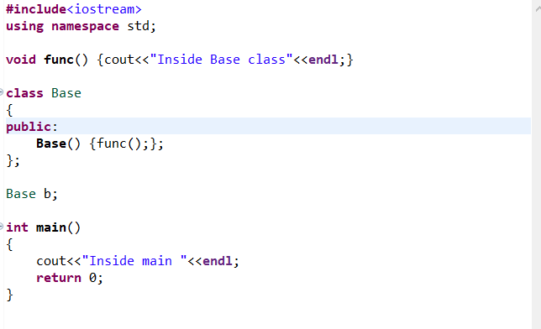

10.When to use Initialiser list in C++
Saturday, April 5, 2025
8:21 PM
  - To initialize non-static constant datamember of a class
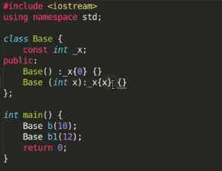

  - To initialize baseclasss datamember from child class
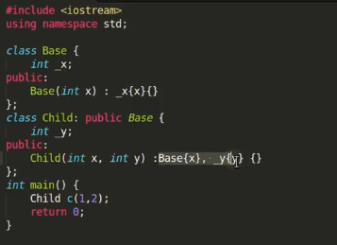

11.Why return by reference is unsafe sometimes
Saturday, April 5, 2025
8:29 PM

- Return by reference of local variables lead to undefined behaviour as the variable will be destroyed once the function ends
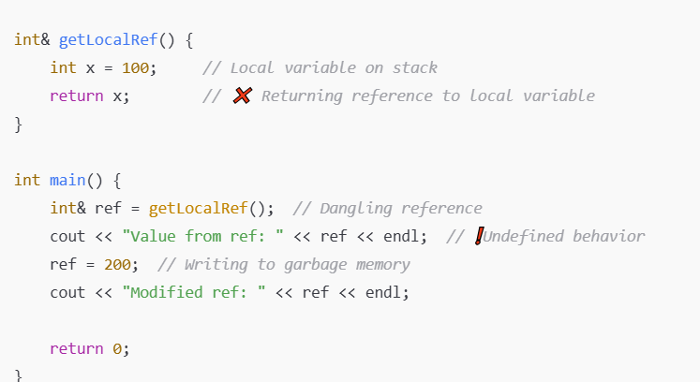

SAFE Implementation
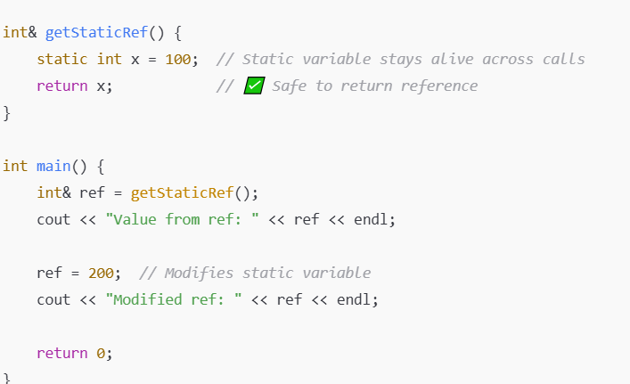

12.Static_Variables_In_Template_Class_vs_Template_Functions
Sunday, April 6, 2025
8:51 AM

- Static Variables in Template Classes
  - Each template instantiation gets its own copy of the static variable.
  - For TemplateClass<int> and TemplateClass<float> ,the static variables are distinct
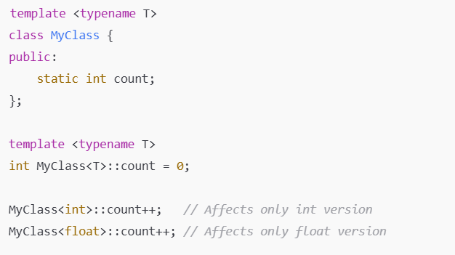
- Type specific static data exist across all objects of the type.
- Static Variables in Template Functions
- Static variables are distinct for each template instantiation
- Each function<T>() gets its own static variables.

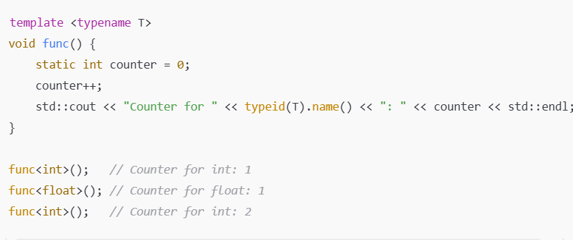

- Type-specific state will be shared within a template function.

13.Extern 'C' in C++
Sunday, April 6, 2025
10:40 AM
  - We use extern 'C' when we write C++ code and include c code in that
  - C++ compilers mangle function names to support operator overloading .
  - C does not mangle names - so to call C functions from C++ ,or to expose C++ functions to C ,we need to use extern "C".
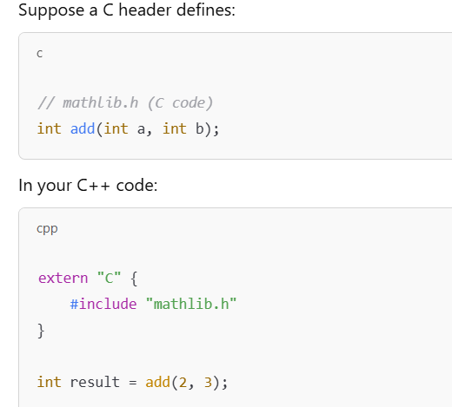

  - Extern keyword tells the C++ compiler to treat add with C linkage

14.Name mangling in C++
Sunday, April 6, 2025
12:36 PM
  - C++ supports features like
    - Function overloading
    - Namespaces
    - Class & member functins
  - To distinguish them during linking ,compiler mangles names.
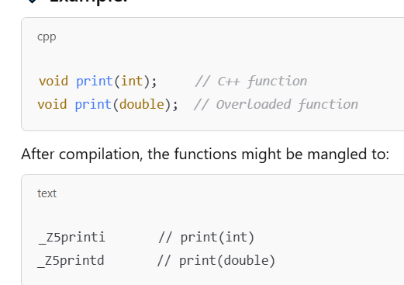

  - 15.Why we need to return references for copy assignment operators
Sunday, April 6, 2025
12:39 PM

  - Enable Chained Assignments
    - Returning a reference to current object (*this ) allows expressions like
      - a=b=c;
      - b = c returns a reference to b.
      - Then a = (b = c) assigns a using that reference
  - Avoid unnecessery copies
    - Return by reference avoids making an extra copy of the object.
    - Return by value invokes another copy constructor or move constructor which is inefficient and unnecessary .

16.Malloc vs Calloc
Sunday, April 6, 2025
11:14 PM
- Malloc() just returns the raw block of memory ,while calloc() fills the memory with zero and return
- There is an extra step in calloc() that makes it slower than malloc().
When to use malloc() vs calloc()?
- Use malloc() when we want to immediately overwrite the memory.
- Use calloc() when you need zero-initialized memory(like arrays or structs with all-zero defaults).

17.Why using namespace std; is a bad practice
Sunday, April 6, 2025
11:20 PM
  - Name conflicts :- using namespace std; dumps all symbols from standard library to the global namespace.This can cause conflict with our own functions or variables
  - Ambiguity in larger projects :- In big codebases ,we might have a function /class with same name as in std.This leads to ambiguous reference or hard to find bugs.
  - Header files nightmare :- - using namespace std; in a header file ,forces every file including it to inherit the namespace mess.
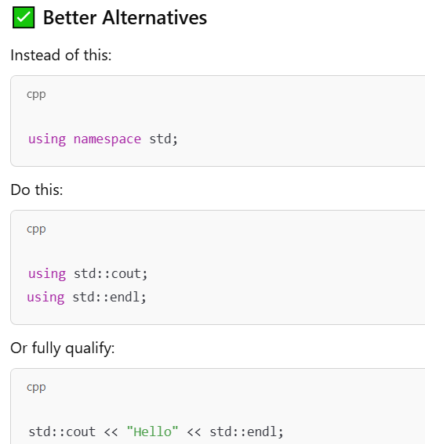

18.Why Template functions are defined only in header files
- Template functions are blueprints and not actual functions until you use them with a specific type .
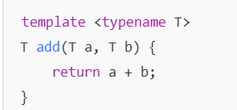
- When you write add<int>(2, 3), the compiler generates int add(int, int) from the template.

🚫 If the definition is only in a .cpp file:
- Compiler won't see the full template code when compiling another files - leading to linker error.
✅ Solution:
Put both the declaration and definition in the header file.

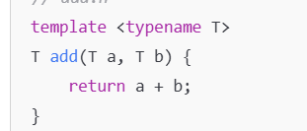

Sunday, April 6, 2025
11:47 PM

19.Overload Pre & Post Increment Operator
Monday, April 7, 2025
8:22 AM

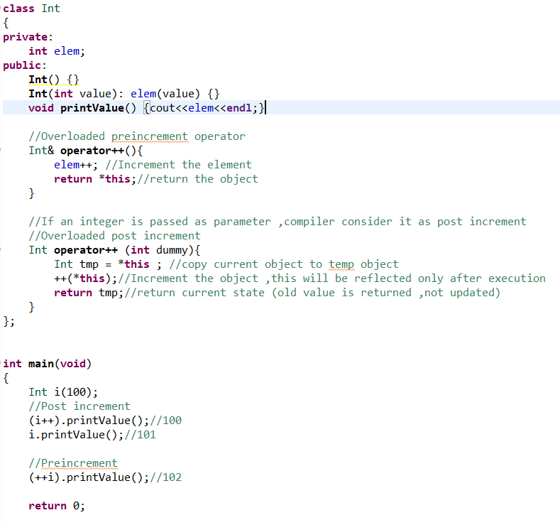

20.Print N number of Times,without using Loop or iterator
Monday, April 7, 2025
8:48 AM
  - We can do this by using Constructor and an array
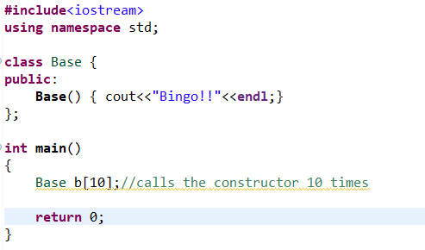
  - Base b[10] calls the constructor 10 times and Bingo will be printed 10 times.

21.Why we need to define Static data members in CPP file and not Header
🛑 What happens if you define in the header?

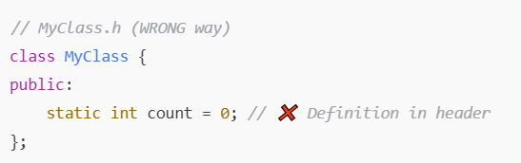
- It creates a definition of the static variable in all cpp files that include file
- This will violate One Definition Rule(ODR) and causes linker errors.

✅ Exception (since C++17)
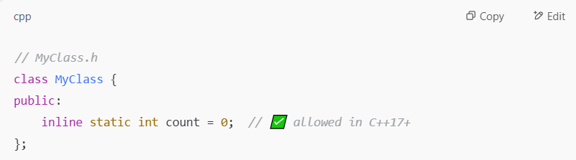
- If we declare a static member as inline we can define it in header.
- Inline tells the compiler ,its ok to have multiple definitions as long as they are identical.

Monday, April 7, 2025
9:00 AM

21.Segmentation Fault
Monday, April 7, 2025
9:34 AM
  - Segmentation Fault occurs due to memory access violation such as
    - Stack overflow
    - Write violation
    - Read violation

e.g i) Dereferencing NULL
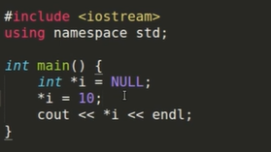
ii) Stack Overflow
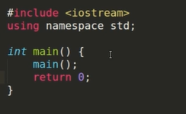

22.Implement Custom String Class - IBM
Thursday, April 10, 2025
10:14 AM

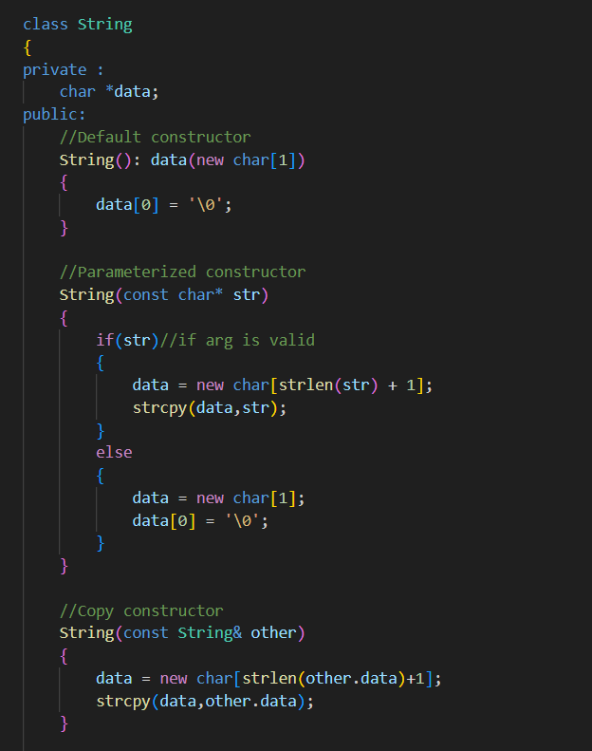

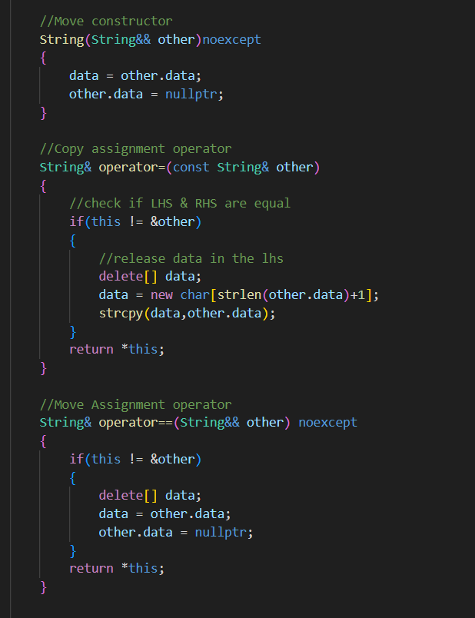

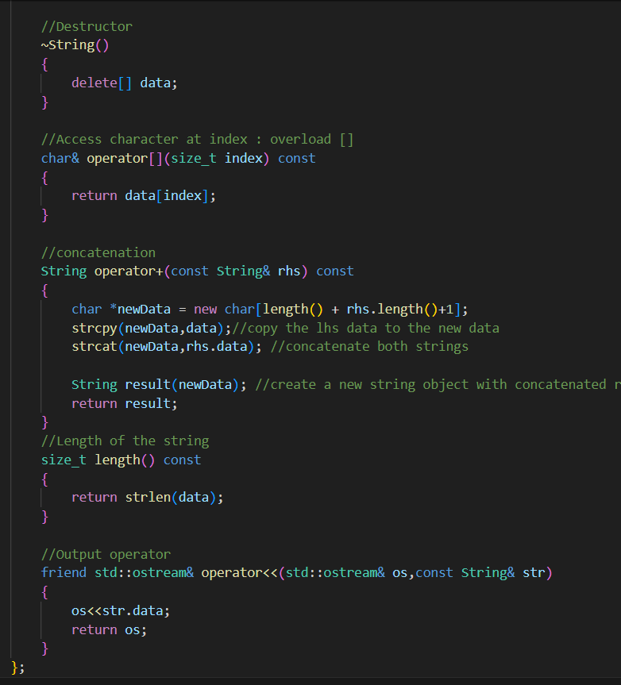

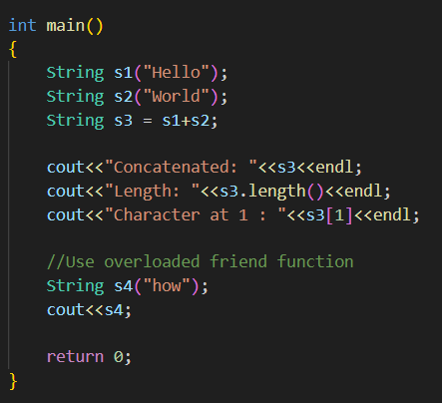

23.Exception handling , Creat Custom Exception in C++
Thursday, July 17, 2025
1:26 PM

24.Pyramid program
Thursday, July 17, 2025
1:27 PM

25.Greedy Approach : Problem solving
Thursday, July 17, 2025
1:29 PM

26.Observer Design pattern
Thursday, July 17, 2025
1:30 PM

27.Custom STL vector
Wednesday, July 23, 2025
1:03 PM

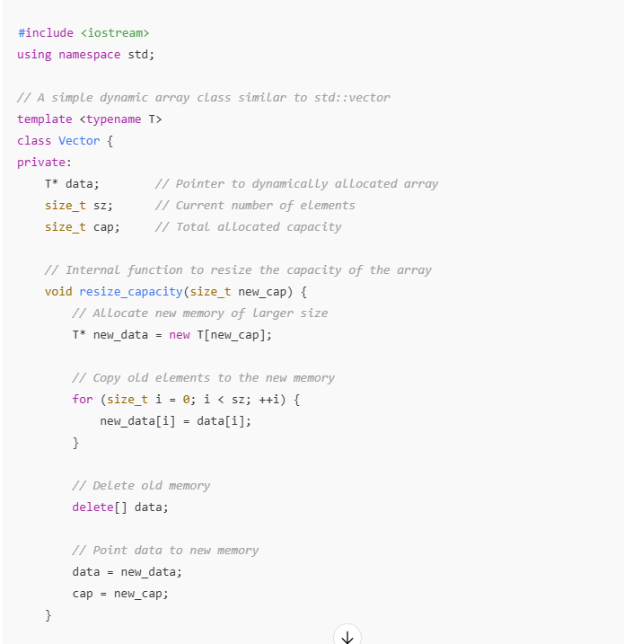

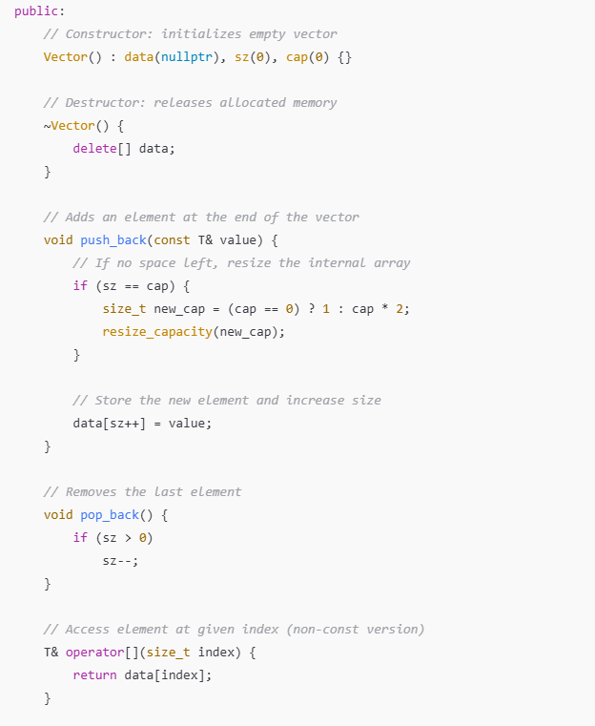

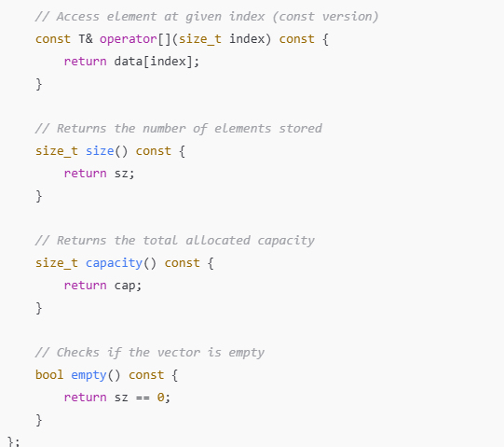

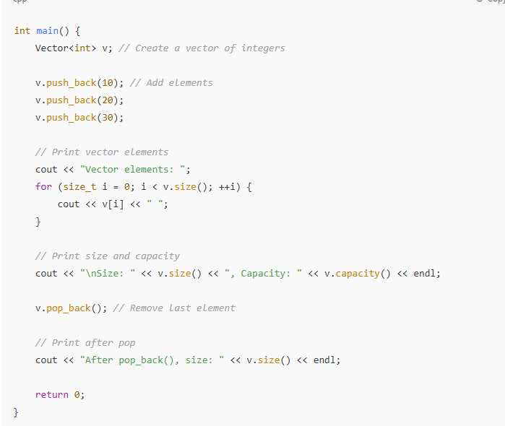

28.Implement a Ring buffer - Phillips
Thursday, July 24, 2025
3:55 PM

📘 Ring Buffer in C++
A ring buffer (or circular buffer) is a fixed-size data structure that wraps around upon reaching the end, forming a logical circle. It is especially useful in scenarios like streaming, producer-consumer problems, and embedded systems where memory is limited and continuous data flow needs efficient handling.

🔧 Key Characteristics:
- Fixed Size: Pre-allocated memory to avoid dynamic resizing.
- Two Pointers:
  - head → where new data is removed from
  - tail → where data is added
- Wrap-around Logic: When the end is reached, indices reset to the beginning.

🧠 How it Works:
- Enqueue (Add):
  - Add data at head
  - Advance head (with wrap-around using modulo)
  - If buffer is full, it may overwrite oldest data or block (based on design)
- Dequeue (Remove):
  - Read data from tail
  - Advance tail

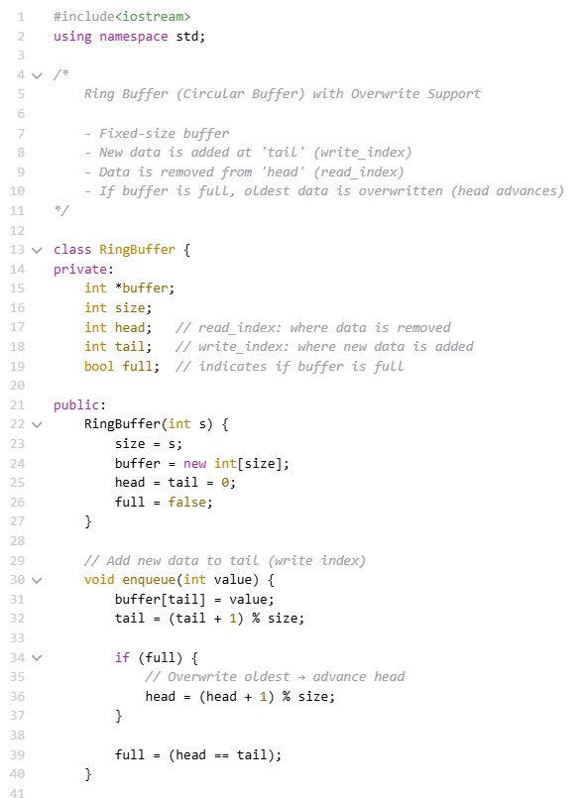

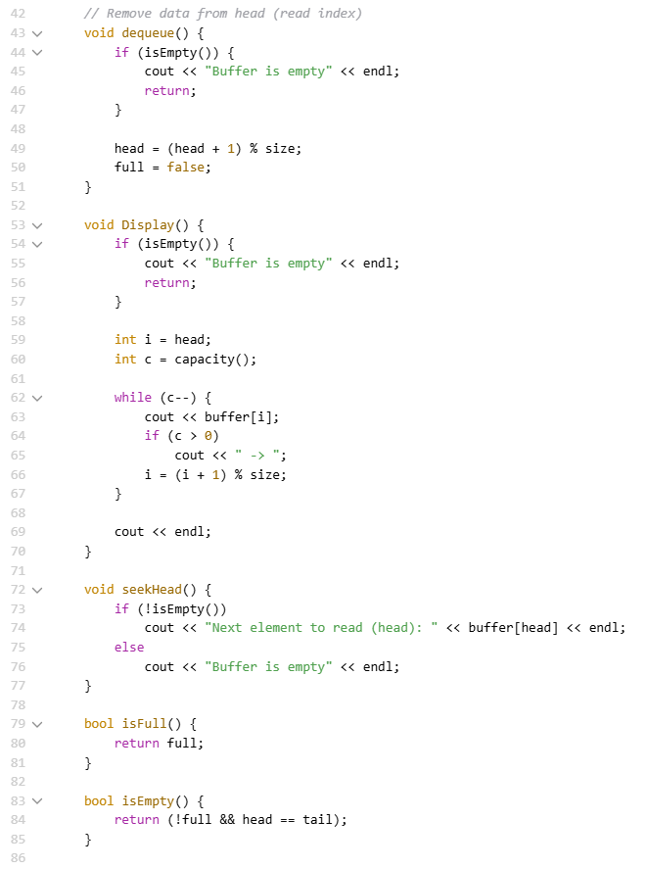

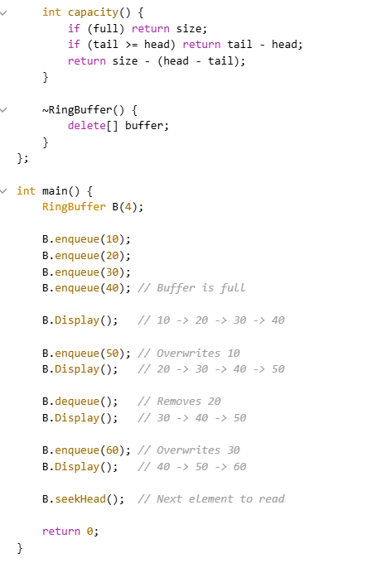

29.Composition and Aggrigration
Thursday, July 24, 2025
3:56 PM
🔹 Composition (Strong Association)
- Definition :- Composition is a "has-a" relationship where one class owns another class.
- Lifetime Dependancy :- Lifetime of contained object depends on the lifetime of container object.
- Tight Coupling :- If the container is destroyed ,the contained object is also destroyed .
✅ Example:
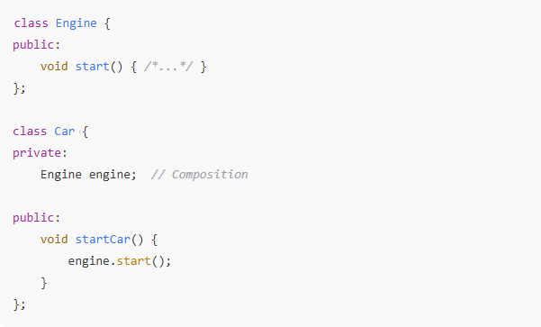
In this case, Car owns the Engine. When Car is destroyed, the Engine is also destroyed.

🔹 Aggregation (Weak Association)
- Definition :- Aggregation is a "has-a" relationship,but the contained object is not owned by the container
- Lifetime Dependancy:The lifetime of the container and contained object are independent
- Loose Coupling :- Object can exist independently
- 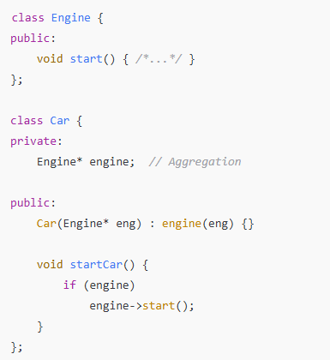

- Here, Car uses Engine but does not own it. The same Engine can be shared among multiple Car objects.

30.Find the bug in the code - Phillips
Thursday, July 24, 2025
3:56 PM

HINTS : C++ program
CTImer & Cobject
->Vector of Ctimer pointers.
C object will check for the id and remove
There is add function
=>These are all I could remember ,generate a interview qs (concept memory leak)
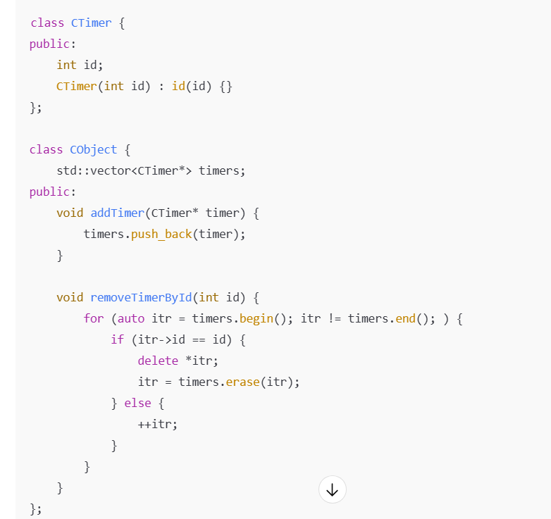
❓ What’s the Bug?
- What's wrong with the removeTimerById function?
- How would you fix it to prevent memory leaks or crashes?

✅ Expected Answer:
- itr is a std::vector<CTimer*>::iterator
- So *itr is a CTimer*
- Therefore, (*itr)->id is the correct way to access id
✅ Correct Line:
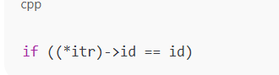
❌ Buggy Version with Double Increment:

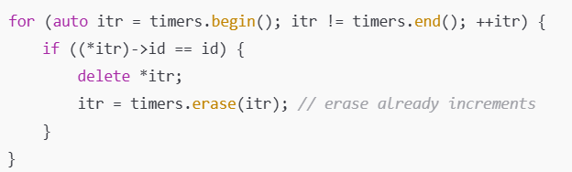
⚠️ Bug Explanation (Double Increment):
- timers.erase(itr) returns the next valid iterator, so assigning it back to itr is correct.
- But the loop also does ++itr, which causes the iterator to skip the next element or even go past end() and cause undefined behavior.
- This is a very common and subtle bug.
✅ Corrected Loop — No Double Increment
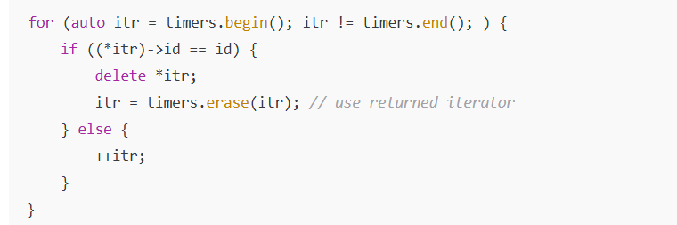

31.Create odd and even thread than prints consecutevely
Tuesday, September 23, 2025
6:02 PM
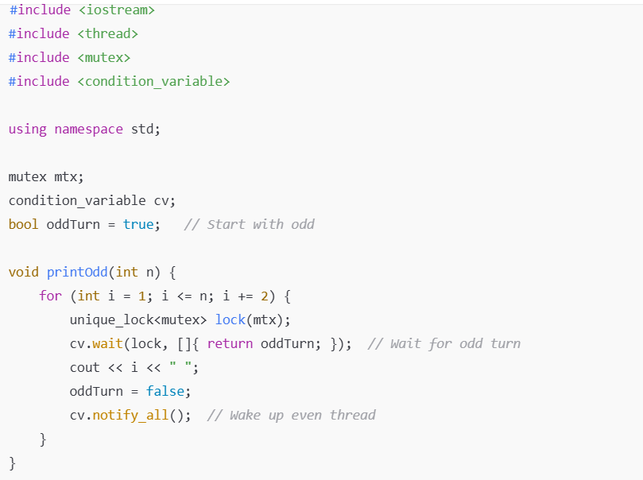

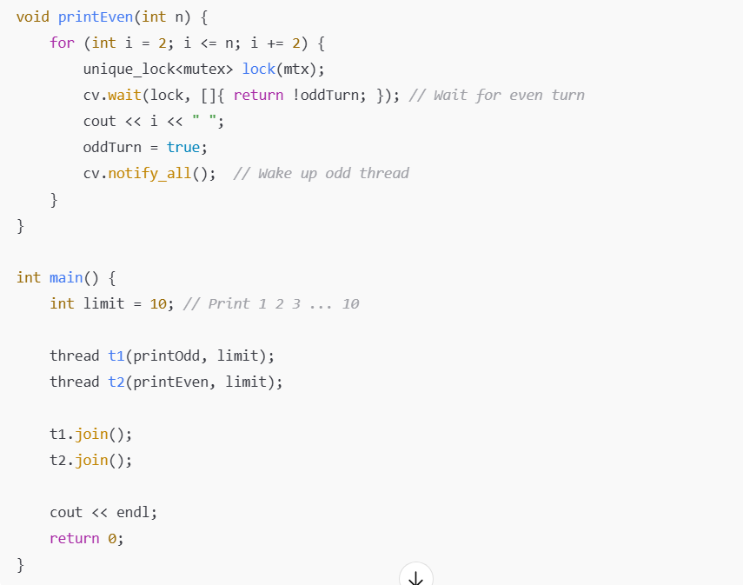

32.Delete from end of linkedlist
Tuesday, September 23, 2025
6:02 PM

33.Create a 2-D Array in Heap
Wednesday, September 24, 2025
12:19 PM

34.Can const variables be modified
Thursday, October 9, 2025
9:18 PM

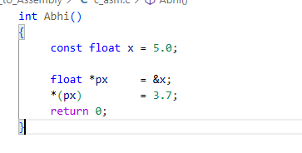
- Const keywords just tells compiler to treat the variable as read only .While we can access the memory location of the variable using pointers and modify the value(provided memory is read only )

